SDAP Data Request #10
SDG&E PHASE 2 GRC PROCEEDING - A.19-03-002
DATE RECEIVED: July 13, 2020
DATE RESPONDED: July 24, 2020

SDG&E’s responses are in Blue font.

SDAP Link to DR and Work Paper: https://drive.google.com/drive/folders/14wJGuKsPkSCN4P6k0udqN30jk1Ovw6js?usp=sharing

- Demand Waiver AL 3115-E:
In SDAP’s testimony, SDAP addresses and proposes for a resolution regarding the same issue it had in 2016 with SDGE, in that there was no commercial rates available for its EV charging load tied to its facility meter and thereby the commission approved a 3 year waiver on the small commercial TOU-A rate. Ordering Paragraph 37, See Appendix attachment 1 : AL 3115-E
  - Is there a rate today for SDAP or other small commercial sites (> 40 kW – 60 kW) for EV charging that is not separately metered? (besides AL-3115-E)
SDG&E Response: EV loads that are not separately metered from building loads are eligible for otherwise applicable SDG&E commercial rates.

  - If not, why not?
SDG&E Response: The CPUC has not approved EV rates for non-separately metered load.

  - Isn’t it true that some customers cannot install a separate meter?
SDG&E Response: SDG&E is not aware of all of the factors that may discourage or prevent a customer from installing a separate meter.

  - How do you plan to resolve this issue?
SDG&E Response: SDG&E objects to this request as vague and ambiguous, particularly with respect to the phrase “this issue.” Accordingly, SDG&E is unable to respond.

  - Based on if SDGE has a resolution as per item d answer, does your resolution resolve the impact of demand fees for these low load factor users?
SDG&E Response: See response to question 1.d.

  - What solution have you offered to SDAP?
SDG&E Response: See response to question 1.d.

  - Do you have a temporary or interim rate available that you will consider as an option to settle this issue?
SDG&E Response: See response to question 1.d.

  - Does this resolve the effects of Demand?
SDG&E Response: See response to question 1.d. SDG&E further objects to this request as vague, ambiguous and unintelligible because “this” is undefined. Accordingly, SDG&E is unable to respond.

  - Does this rate provide an incentive to access electricity as a fuel to assist in grid management?
SDG&E Response: See response to question 1.d and 1.h. SDG&E further objects to this request as vague, ambiguous and unintelligible because “this rate” is undefined. Accordingly, SDG&E is unable to respond.

  - Does this rate provide an incentive to charging during the over generation period when renewables are integrated and GHG is lowest?
SDG&E Response: See response to question 1.d. SDG&E further objects to this request as vague, ambiguous and unintelligible because “this rate” is undefined. Accordingly, SDG&E is unable to respond.

  - Please explain how your solution addresses the following:
      - SB1000
      - Fuel switching benefit
      - Best pricing is accessible during lowest GHG times of day
SDG&E Response: See response to question 1.d. SDG&E further objects to this request as vague, ambiguous and unintelligible because “your solution” is undefined. Accordingly, SDG&E is unable to respond.

- Sub-Metering:
In SDG&E’s initial application for an EV-HP rate (A. 19-07-006), SDG&E witness Syz notes that the utility “proposes to offer a new optional rate applicable to separately-metered DCFC.” Exhibit BS-4, (July 3, 2019).

  - Do you offer a rate for Sub-metered EV Load?
SDG&E Response: The proposed EV-HP rate is an optional rate for separately-metered EV charging. Sub-metered EV load is not eligible.

  - If not, why not?
SDG&E Response: SDG&E has not proposed an EV rate specific to sub-metered EV load.

  - When will you?
SDG&E Response: SDG&E has no plans to propose additional EV rates at this time.

  - Will this include load that is EV charging regardless of AC or DC?
SDG&E Response: See response to question 2.c.

  - If not, why not?
SDG&E Response: See response to question 2.c.

- TOU-A Rate Summary and has the following Present Rates and TOU Periods including the GRC-2 changes updated from 5-4-20:

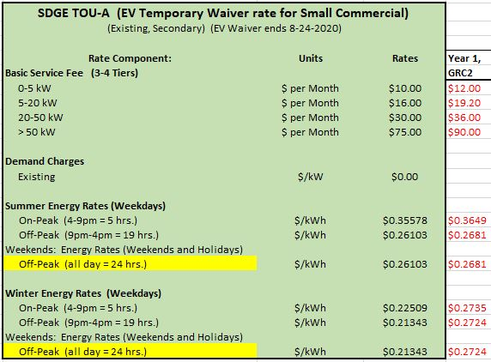

- TOU-M Rate Summary and has the following Present Rates and TOU Periods including the GRC-2 changes updated from 5-4-20:
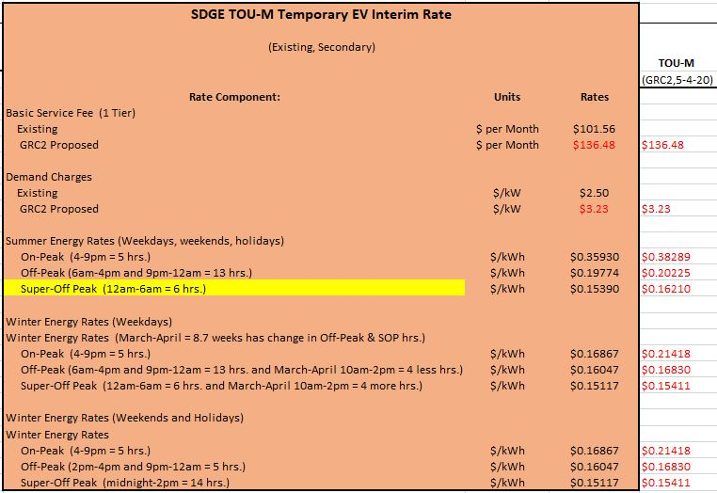

- EV-TOU-5 Rate Summary and has the following Present Rates and TOU Periods including the GRC-2 changes updated from 5-4-20:

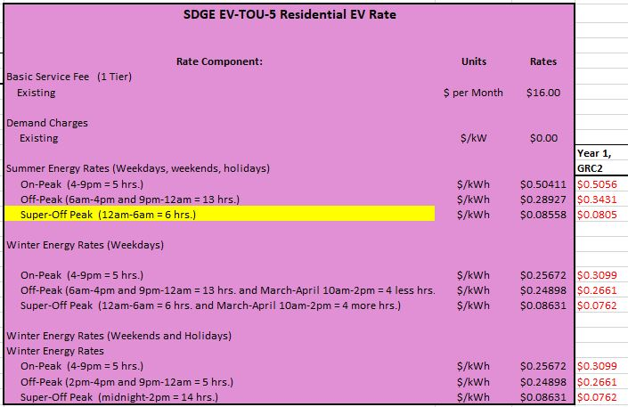

- TOU Hrs. compared has the following results in EV-TOU-5 to TOU-M & EV-TOU-5:

  - Week-Day Results
  - Week-End Results
  - Overall Annual Results

The below tables on the next three pages includes the comparison of the TOU Hours for Week-Days, Week-Ends, and Annual Results. The last Table with colors includes “Scale of Values”.
The scale of Values are related to the three TOU periods and are depicted as the following:

1 = SOP in Green
2= OFF PEAK in Yellow
3= PEAK in Red.

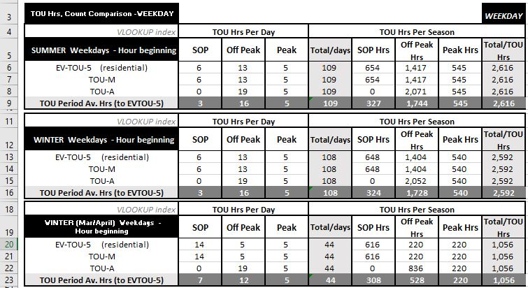

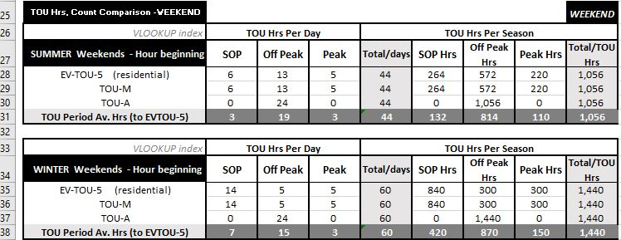

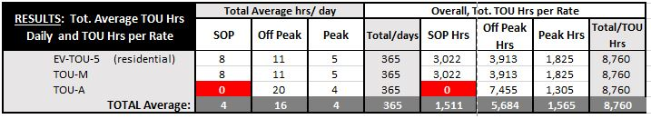
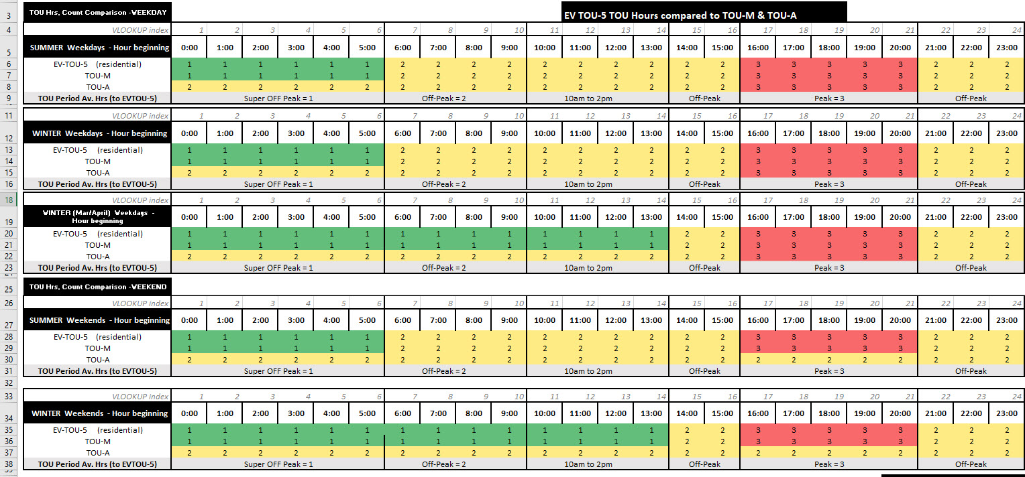
  - TOU-A TOU Hours Results Summarized:

  - SOP = 0, Off Peak=7455, Peak=1305 Hours annually.
  - Do you agree that in TOU-A, there are “NO” Super Off-Peak Rates?

SDG&E Response: TOU-A is a two-period TOU rate; therefore, it only has two periods: on-peak and off-peak.
  - Do you agree that the rate is flat 100% of the time on Weekends, which is a total of approximately 104 days per year?

SDG&E Response: The on-peak period for Schedule TOU-A is 4PM-9PM, year-round, weekdays and weekends. Therefore, the rate varies on weekends, and is not “flat.”

  - Do you agree that the rate on Winter Week-days is also fairly flat, a total of approximately another 152 days per year?

SDG&E Response: SDG&E objects to this request as vague and ambiguous because “fairly flat” is undefined and subjective. Accordingly, SDG&E is unable to respond.

  - Do you agree that the rate on Summer Week-days provides a ratio differential that could influence charging to be avoided at the 5 Peak Hours?

SDG&E Response: SDG&E objects to this request on grounds that it calls for speculation. Subject to this objection, SDG&E responds as follows. Generally, TOU rates with higher on-peak differentials are designed to incentivize charging in non-peak hours.

  - Do you agree that all other Summer Week-day hours,19 hours, are flat, at a total of another approximate 109 days x 19 hours?

SDG&E Response: There are two TOU periods in Schedule TOU-A. The Off-peak period is effective for 19 hours per day, year-round, and rates do not vary by price during this time.

  - Do you agree based on the TOU-A Tariff Schedule and its TOU hours, this rate provides 5-Summer Peak Hours which is about 109 days and a total of approximately 545 hours out of 8760 annual hours --- that could incent charging at other hours in a day due to the ratio differential in the hourly rate price.

SDG&E Response: SDG&E objects to this request on grounds that it calls for speculation. Subject to this objection, SDG&E responds as follows. Generally, TOU rates with higher on-peak differentials are designed to incentivize charging in non-peak hours.

  - If you do not agree to any of the above, please explain why not.

SDG&E Response: See response to question 6.k.

  - Please provide corrections to any of the above.
  - Would you characterize the TOU-A rate as fairly flat on all days except for the Summer Weekday months at the Peak Hours?

SDG&E Response: SDG&E objects to this request as vague and ambiguous because “fairly flat” is undefined and subjective. Accordingly, SDG&E is unable to respond.

  - Do the TOU-A rates align with the lowest GHG hours?

SDG&E Response: SDG&E objects to this request to the extent that it seeks analysis that has not been performed and/or information that would be unduly burdensome to produce.

  - Please explain.
  - Explain how does a flat rate incent EV Charging?

SDG&E Response: SDG&E objects to this request as vague and ambiguous because “flat” is undefined and subjective. SDG&E further objects to this request as calling for speculation as to customer incentives. Accordingly, SDG&E is unable to respond.

- SB350 Rate Design Requirements is to Accelerate Widespread Transportation electrification:
  - Can you please explain what current rate(s) satisfies SB350 for an EV user with EV charging on a facility meter for a small commercial customer?
SDG&E Response: SDG&E objects to this request as vague and ambiguous, particularly with respect to the phrase “satisfies SB350.” Accordingly, SDG&E is unable to respond.

  - In your opinion, what are your best designed rates for EV charging that exist in SDGE’s EV Rate choices?
SDG&E Response: SDG&E objects to this request on grounds that it calls for speculation. Subject to this objection, SDG&E responds as follows. Which SDG&E rates offer the best customer experience for EV charging customers will depend on individual customer consumption and preferences.

  - Do these rates reduce the effects of Demand Charges on Low Load factor users from EV charging?
SDG&E Response: Please see the response to 7b.

  - Off-peak charging delivers greater environmental benefits, what Rate schedules are designed to influence the Electric Vehicle owners' charging behavior and encourage customers to charge their vehicles during off-peak periods?
SDG&E Response: SDG&E objects to this request on grounds that it calls for speculation. Subject to this objection, SDG&E responds as follows. Generally, TOU rates with higher on-peak differentials are designed to incentivize charging in non-peak hours.

  - Are these rate(s) eligible for small commercial customers that will have a load between 40-60kW?
SDG&E Response: The proposed EV-HP rate is intended to be applicable to all non-residential, separately metered EV charging customers with maximum demand over 20 kW.

  - If not, which rates apply for this type of EV customer?
SDG&E Response: See response to question 7.e.

  - Which rates incent charging behaviors based on rate design?
SDG&E Response: SDG&E objects to this request as vague and ambiguous as to rates being referenced. Accordingly, SDG&E cannot respond.

- Zero -Emission Airport Shuttle Bus California Law, (Appendix Attachment 3)
Do you agree that SDAP and other California Airport Shuttle vocations are required under the California Office of Administrative Law (OAL) which approved the rulemaking and was filed with Secretary of State on January 30, 2019 and the effective date of the law is April 1, 2020 --- that these fleets must transition to 100% ZEV’s?

      - https://ww3.arb.ca.gov/regact/2019/asb/fro.pdf
      - https://www.google.com/url?client=internal-element-cse&cx=001779225245372747843:jjy6ey8hexa&q=https://oal.ca.gov/california_regulatory_notice_online/january-2019-california-regulatory-notice-registers/&sa=U&ved=2ahUKEwj8serCosnqAhUJjq0KHQ-tDlwQFjAAegQIBRAC&usg=AOvVaw0kWL2We6EC3u8p9Z16W2HI

SDG&E Response: SDG&E objects to this request on the grounds that it calls for a legal conclusion rather than the production of evidence or clarification of factual matter.

  - Do you agree that Transit bus vocations in California must also transition to ZEV’s?
      - https://ww3.arb.ca.gov/msprog/ict/ict.htm

SDG&E Response: SDG&E objects to this request on the grounds that it calls for a legal conclusion rather than the production of evidence or clarification of factual matter.

- Low Load Factor adjustment?
The “average” demand rate and effective energy consumption between small EV commercial customers and large EV commercial customers with utilization from EVSE Charging that includes both energy and kW power can be Diverse. What EV commercial rates does SDGE have that reflects a differential between the small and large commercial customer classes when the load is between 40-60kW for a small commercial customer?

  - Do you agree that Residential drivers, can use 100 kW at a public charging station and can receive a residential rate?
SDG&E Response: No, commercial 100 kW DC Fast Charging stations installed outside of utility programs are currently metered on existing Medium/Large Commercial & Industrial rates.

  - Do you agree that residential EV drivers are being adjusted from the effects of demand when EV charging at 50 kW or 100 kW?
SDG&E Response: SDG&E objects to this request as vague, ambiguous and unintelligible. Accordingly, SDG&E cannot respond.

  - If not, why not?
SDG&E Response: See response to question 9.b.

  - Why is it that small commercial customers have no adjusted rate for EV Charging load when between 40-60kW after AL 3115-E expires?
SDG&E Response: SDG&E has proposed the EV-HP rate as an optional EV rate for separately metered non-residential EV charging loads over 20 kW.

  - Do you agree that there is diversity of loads and energy consumption (low load factor) between the small commercial EV customers when utilizing EV charging compared to ML/CI EV customers?
SDG&E Response: SDG&E is not aware of systemic differences in load factors between EV charging customers in the Small Commercial and Medium/Large Commercial & Industrial customer classes.

  - If not, why not?
SDG&E Response: See response to question 9.f.

- Commercial fleet user Scenario achieves 20 MPG in Diesel and achieves 1 kWh per Mile in an EV and will use EV charging in both the Off Peak or daytime as well as SOP hours and the 2020 fuel prices are the following:

  - San Diego Fuel Prices for July 2020, Average price per gallon in San Diego:
  - Fuel is $3.13 per gallon / 20 MPG = $0.16 per mile (see table on next page)
      - https://www.fueleconomy.gov/feg/gasprices/states/ca.shtml
      - http://www.sandiegogasprices.com/index.aspx?fuel=D
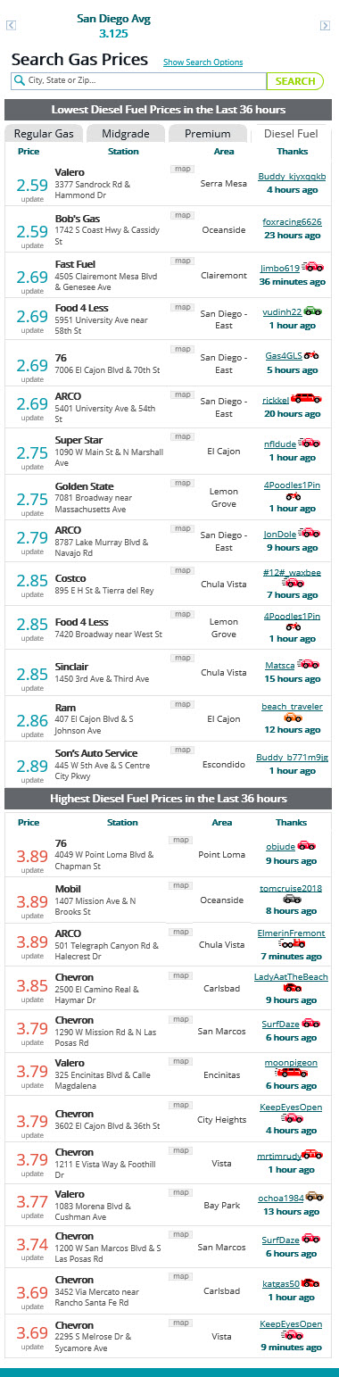
  - California Fuel Prices in 2020, Average price per gallon:
  - Fuel is $3.49 per gallon / 20 MPG = $0.17.5 per mile (see table below)
      - https://www.eia.gov/dnav/pet/pet_pri_gnd_dcus_sca_m.htm

  - Both the San Diego and California Fuel Prices include all taxes and thereby this is the “out the door and adjusted” price per gallon. There are no networking fees or maintenance fees for the diesel fueling cost.

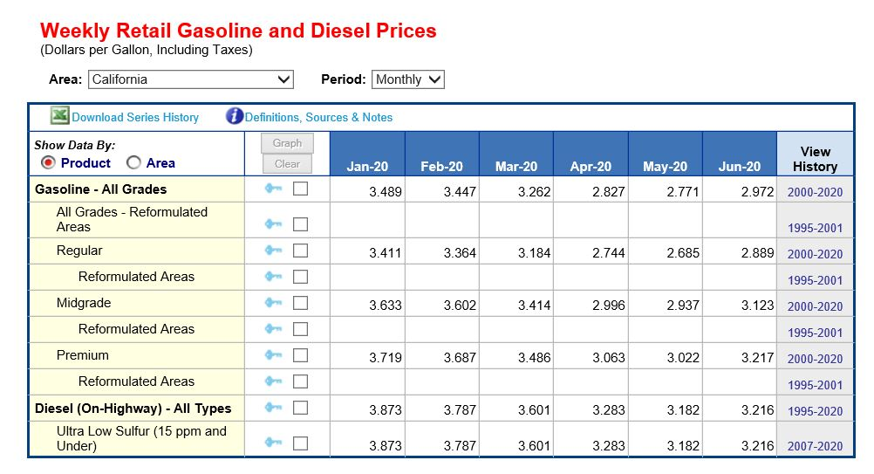

  - In this scenario it results in a price per gallon of as low at 16 cents per mile or up to 17.5 cents per mile. If an EV vehicle that replaces this diesel vehicle and achieves 1 kWh per mile --- do you agree that the price per kWh would need to be 16 to 17.5 cents to be equal with Diesel?
SDG&E Response: SDG&E objects to this request to the extent it seeks analysis not performed by SDG&E and is based on information equally available to SDAP.

  - If there is a Meter Loss, then this would add cost, correct and would be incremental cost to the kWh used by the EV fleet?
SDG&E Response: SDG&E objects to this request to the extent it seeks analysis not performed by SDG&E and is based on information equally available to SDAP.

  - If there is a Monthly Networking Fee, then this would add cost, correct and would be incremental cost to the energy cost?
SDG&E Response: SDG&E objects to this request to the extent it seeks analysis not performed by SDG&E and is based on information equally available to SDAP.
  - If there is a Monthly Maintenance Fee then this would add cost, correct and would be incremental cost to the energy cost?
SDG&E Response: SDG&E objects to this request to the extent it seeks analysis not performed by SDG&E and is based on information equally available to SDAP.

  - If there are City of Franchise Fee Tax, State Surcharge Tax, State Regulatory Fee, Electric Energy Supplied by Others Fees --- all of these ‘Taxes and Fees on Electric Charges’ would add cost, correct and would be incremental cost to the energy cost?
SDG&E Response: SDG&E objects to this request to the extent it seeks analysis not performed by SDG&E and is based on information equally available to SDAP.

  - Do you agree that all these costs itemized above (g-j) are unique to EV Charging in this scenario illustrated for the feet that displaces from diesel and owns the charger?
SDG&E Response: SDG&E objects to this request to the extent it seeks analysis not performed by SDG&E and is based on information equally available to SDAP.

  - Do you agree that in order for the diesel fleet to compare if there is a fuel switching benefit as per this illustration, that the Meter Loss, Monthly Networking Fee, Monthly Maintenance Fee, Taxes and Fees on Electric Cost would need to be included to determine the total EV cost per mile to the 17.5 cents per diesel gallon cost ?
SDG&E Response: SDG&E objects to this request to the extent it seeks analysis not performed by SDG&E and is based on information equally available to SDAP.

      - If not, why not and explain.
  - Which SDGE present EV rate would provide a benefit to driving an EV as per this scenario and that could be better than 17.5 per kWh (adjusted and out the door kWh)?
SDG&E Response: SDG&E objects to this request to the extent it seeks analysis not performed by SDG&E and is based on information equally available to SDAP.

- TOU-M Rate: (see item 4 table)

  - Do you agree that the TOU Period for TOU-M small commercial is the exact same TOU period as the EV TOU residential rates?

SDG&E Response: All standard TOU rates (non-“grandfathered”, TOU period rates) have the same TOU periods, including TOU-M and EV-TOU.

  - If not, why not?
SDG&E Response: See response to question 11.a.

  - Do you consider all the Winter hourly Rates fairly Flat in TOU-M?

SDG&E Response: SDG&E objects to this request as vague and ambiguous because “fairly flat” is undefined and subjective. Accordingly, SDG&E is unable to respond.

  - If not, why not?

SDG&E Response: See response to question 11.d.
- EV-TOU-5 Rate: (see item 5 table)

  - Do you agree that the TOU Period for EV-TOU-5 is the same as the small commercial rates for the TOU-M?

SDG&E Response: All standard TOU rates (non-“grandfathered”, TOU period rates) have the same TOU periods, including TOU-M and EV-TOU-5.

  - Do you agree that there are more hours in the EV-TOU-5 rate with pricing differentials that could incent charging to the SOP and Summer Off peak hours than in TOU-M and TOU-A?

SDG&E Response: SDG&E objects to this request as vague, ambiguous and speculative because it is based on an incomplete hypothetical. Accordingly, because SDG&E does not have sufficient knowledge or information upon which to admit or deny the claim, and on that basis denies that it is true.

  - If not why?

SDG&E Response: See response to 12.b.

- SDGE EV-TOU Residential Rate, Do you agree that SDGE’s EV-TOU rate that is a residential rate is being used at commercial sites for retail commercial customers?

  - If not, why not?
SDG&E Response: Yes, the EV-TOU residential rate was approved by the CPUC for use at select public charging stations in Commission Decisions D.18-01-024 and D.19-11-017.

  - How many current commercial sites are using an EV TOU rate at a location?
SDG&E Response: As approved in D.18-01-024 and D.19-11-017 sites in the Electrify Local Highways Priority Review Project and Power Your Drive for Schools and Parks Pilots are billed on the EV-TOU rate.

  - How many estimated commercial sites will be using an EV TOU rate per other Decisions such as AB1082/AB1083 D.19-11-017?
SDG&E Response: See response to question 13.b.

  - Are there any other Decisions that are eligible for an EV TOU rate?
SDG&E Response: D.18-01-024 and D.19-11-017 are the only decisions that authorize billing non-residential customers on the EV-TOU rate.

  - Are there any other Applications that SDGE has filed that are currently in progress and that include an EV-TOU residential rate that is Proposed by SDGE?
SDG&E Response: No, SDG&E has no open applications that proposed to use the EV-TOU residential rate at commercial sites.

- Electrify Highway Cal Trans Sites: (per D.18-05-040, OP 21).

  - Is the site maximum at the four Electrify Highway Cal Trans sites at close to 259 kW?
SDG&E Response: Yes, the installed charging capacity of a SDG&E Electrify Local Highway site is approximately 250 kW.

      - If not, why not. Please correct and explain answer.
      - Do these four sites use an EV TOU residential rate?
SDG&E Response: Yes per D.18-01-024 sites at this Priority Review Project are billed on the EV-TOU rate.

      - Does this include EVSE infrastructure per site of twenty level-2 chargers and two DCFC chargers?
SDG&E Response: Yes, this is correct.

- Schools AB1082 and Parks/Beaches AB1083:

  - Schools AB1082 includes an estimated 30 sites.

  - The illustrated stations per site per Table A-4 in SDGE’s Chapter 1 RS Testimony states the following minimum and maximum EVSE count per site:

      - A minimum of four level 2 at approximately a maximum of 26 kW per site. Is this correct?
SDG&E Response: Yes, this is approximately correct.
        - If not, why not. Please correct and explain answer.

      - A maximum of eight level 2 with two DCFC at approximately a maximum of 153 kW per site. Is this correct?
SDG&E Response: Yes, this is approximately correct.

        - If not, why not. Please correct and explain answer.

  - Parks and Beaches AB1083 includes an estimated 22 sites.

  - The illustrated stations per site per Table A-5 and A-6 in SDGE’s Chapter 1 RS Testimony states the following minimum and maximum EVSE count per site:

      - A minimum of four level 2 at approximately a maximum of 26 kW per site. Is this correct?
SDG&E Response: See answer to question 15.b.1.
        - If not, why not. Please correct and explain answer.

      - A maximum of ten level 2 with two DCFC at approximately a maximum of 167 kW per site. Is this correct?
        - If not, why not. Please correct and explain answer.
SDG&E Response: See answer to question 15.b.2.

- In SDGE’s application A.18-07-023 for AB1082/1083 (Schools, Parks and Beaches), you identify the Annual Network and Maintenance Fees (annual service fees) in your budget for the chargers and that some of this was front loaded for a period of time.

  - With respect to these associated annual services fees included in Decision 19-11-017 how many years of the annual service fees are covered?
  - In your budget, what is the annual network fee per Level 2 charger?
  - In your budget, what is the annual maintenance fee per Level 2 charger?
  - In your budget, what is the annual network fee per DCFC charger?
  - In your budget, what is the annual maintenance fee per DCFC charger?
  - If the site host ends-up owning the chargers, are the annual fees for the service cost to be borne by the site host?
  - What does the rebate include for site host that will own their own chargers as it relates to these annual fees?
    - How much of the rebate is the annual fees?
    - How many years does this cover?

- SDG&E Response: SDG&E objects to this request pursuant to Rule 10.1 of the Commission’s Rules of Practice and Procedure on the grounds that it seeks the production of information that is neither relevant to the subject matter involved in the pending proceeding nor reasonably calculated to lead to the discovery of admissible evidence.

- SDGE owns chargers in other programs, did you obtain approval for the annual service fees cost in any of these other decisions?

  - If not, why not?
  - In these other applications, did you request a budget for approval of these cost?
  - If not, why not?
  - If site owners and or fleet customers must pay for annual service fees, then this will add to their operating cost. Please explain if SDGE has created an option for a level playing field to compensate for equivalent fuel switching benefits for these customers when they own the equipment.
  - Do you agree that the annual service fees are incremental to owning and operating a fossil fuel vehicle?
  - Do any of your commercial EV rates take this cost into account for site owners that own the chargers?
  - If not, why not?
  - Are you offering rebates to site owners to cover this cost?
  - If there is no rebate to cover this cost, do you agree that this will create more cost per mile to these customers as this impacts the operational cost for running an EV fleet?

- SDG&E Response: SDG&E objects to this request pursuant to Rule 10.1 of the Commission’s Rules of Practice and Procedure on the grounds that it seeks the production of information that is neither relevant to the subject matter involved in the pending proceeding nor reasonably calculated to lead to the discovery of admissible evidence.

- AL-TOU: Do you agree that SDGE’s testimony in proceeding A.19-07-006 of B. Syz, July 3, 2019, p. BS-4, lines 1-5 states the following:

“Utility general service rates typically include billing components based on maximum kilowatt (“kW”) power demand – commonly referred to as demand charges – which can result in high bills for DCFC and MD/HD EV customers with low load factors (e.g., high maximum demand relative to energy use). Demand charges can also be confusing to customers. This is especially true when drivers are considering the switch from conventional fuels to electricity.”

  - Do you agree that this statement refers to the impact of demand charges and represents that demand charges could be an issue for EV Charging MHD customers with low utilization?
SDG&E Response: Yes, this statement refers to the potential impact of demand charges on the average cost per kWh of some MD/HD EV customers.

  - If not, why not.
SDG&E Response: See response to 18.a.

- AL TOU / CPP-D Present Rate and Proposed Demand Charges in current GRC-2 Proceeding, SDGE Proposed Rate - Schedule AL-TOU (CPP-D) Updated, May 2020.

  - What are the Present Total Demand Charges?
  - Non-Coincident
  - Summer On Peak
  - Winter On Peak
  - What are the Proposed (5-4-20) Total Demand Charges?
  - Non-Coincident
  - Summer On Peak
  - Winter On Peak

SDG&E Response: The table below shows the “present” and “proposed” demand charges for Schedule AL-TOU (CPP-D) filed in SDG&E’s rebuttal testimony on May 4, 2020, Application 19-03-002:
- GRC-2’s Updated Proposed AL-TOU rate changes and impact on HP EV Proposed Rebuttal Rates in A.1907006.

  - Do agree that changes to the Monthly Fee will impact the HP EV Rate?
SDG&E Response: Yes, changes to the SDG&E AL-TOU rate are expected to impact the proposed EV-HP rate.
  - Do agree that changes to the Demand Fee will impact the HP EV Rate?
SDG&E Response: Yes, changes to the SDG&E AL-TOU rate are expected to impact the proposed EV-HP rate.

  - Do you agree that based on SDGE’s GRC2 Proposal that these rates will Change?
SDG&E Response: Yes, changes to the SDG&E AL-TOU rate are expected to impact the proposed EV-HP rate.

- AL-TOU CPP-D total rate verses the AL TOU rate.
  - Please map out the process and series of steps to obtain the total rate. Include the steps of “how” this information is accessed, where it is located and the steps to follow in order to calculate the total rate.

SDG&E Response: SDG&E’s non-residential tariffs are split into two categories: (1) Utility Distribution Company (UDC) total rates, and (2) commodity rates. The reason for this split is to take into consideration bundled service customers (these customers take commodity services from SDG&E as well as UDC service) versus Departed Load customers (these customers take commodity services from a third-party, not SDG&E, but also take UDC service).

AL-TOU CPP-D is the default commodity portion of SDG&E’s medium and large commercial and industrial (M/L C&I) default Schedule AL-TOU. http://regarchive.sdge.com/tm2/pdf/ELEC_ELEC-SCHEDS_EECC-CPP-D.pdf

All AL-TOU customers, both bundled and Departed Load, take Utility Distribution Company (UDC) services from SDG&E. Because these services and rate components are paid by all customers, SDG&E includes these charges in one tariff called Schedule AL-TOU. http://regarchive.sdge.com/tm2/pdf/ELEC_ELEC-SCHEDS_AL-TOU.pdf

The Total AL-TOU rate would be adding the UDC total rates to the EECC CPP-D rates. The opt-out rate would be adding the UDC total rates to the EECC AL-TOU rates.

      - Explain where the information is accessed.
SDG&E Response: Please see the above response to 1.a.
      - What instructions exist to show me the steps on how the total rate is calculated.
SDG&E Response: Please see the response to 21.a.
      - What is the supplemental rate?
SDG&E Response: If SDAP is referring an opt-out rate option for EECC CPP-D. The opt-out option would be EECC AL-TOU found at the link on sheet 5/6: http://regarchive.sdge.com/tm2/pdf/ELEC_ELEC-SCHEDS_EECC.pdf
      - How does one understand which EECC supplemental rate is the correct one?
SDG&E Response: Schedule EECC is set up by rate schedule. One would need to find the applicable rate schedule name and the commodity rates would be underneath.
      - How does one figure out how much is credited/discounted?
SDG&E Response: SDG&E objects to this request as vague, ambiguous and unintelligible. Accordingly, SDG&E is unable to respond.
      - How does one figure out what rate is added on and to what rate.
SDG&E Response: One would need to identify the applicable UDC total rate and adding the applicable EECC rate schedule to it.
      - Do you characterize this process as uncomplicated and effortless?
SDG&E Response: SDG&E objects to this request and vague, ambiguous and speculative as to the terms “uncomplicated” and “effortless.”
      - If not, how would you characterize this process?
SDG&E Response: As explained above, this process is setup to separate the charges for what bundled versus departed load customers pay.
      - Would you characterize this process as easily understandable for a small commercial customer?
SDG&E Response: SDG&E objects to this request and vague, ambiguous and speculative.

- Billing Access:
  - Do you agree that customers should have access to compare rates, including to CCA?
SDG&E Response: SDG&E objects to this request as exceeding the scope of permissible discovery under Rules 10.1 and 12.6 of the Commission’s Rules of Practice and Procedure, to the extent that it seeks information that is privileged and/or subject to confidentiality protections under Rule 12.6 governing settlement
  - Do you agree that customers should have access to the environmental attributes of a rate in order to educate customers on the best environmental TOU hours?
SDG&E Response: SDG&E objects to this request as vague and ambiguous as to the term “environmental attributes.”
  - What information allows me to compare rates with an easy tool?
SDG&E Response: SDG&E objects to this request on the grounds that it is speculative. Subject to and without waving this objection, SDG&E responds as follows. Please see the response to 22.d.
  - Are there tools available on your site for me to model rate impacts with my load?
SDG&E Response: Yes. For accounts enrolled in SDG&E’s MyAccount, it includes an online comparison of eligible rate options.
  - Does this recommend and advise me on the rate options that are available to me based on my load and location?
SDG&E Response: Yes. Rate analysis and recommendations included in the MyAccount online tool are for the most-common rates for which the account may be eligible.
  - What information allows me to see all my choices of rates based on my business, location, and load?
SDG&E Response: Not all rates are included in the MyAccount online tool. Certain business types such as agricultural, outdoor lighting, or electric vehicle charging accounts (for example) may be eligible for rate options not shown. Eligibility factors also include monthly maximum kW demand level, on-site generation (and the date when generation was installed), Direct Access eligibility and Community Choice Aggregation eligibility.
  - Is this as simple as a drop down of choices?
SDG&E Response: SDG&E objects to this request as vague and ambiguous as to the term “simple.” Subject to and without waving this objection, SDG&E responds as follows. There is a drop down tool.
  - If not, please explain the current process.
SDG&E Response: See response to 22.g.
  - Would you characterize your billing statements as easily understandable for small commercial customers?
SDG&E Response: SDG&E objects to this request as vague, ambiguous and speculative as to the phrase “easily understandable.” Accordingly, SDG&E is unable to respond.
  - If yes, please explain what makes it easily understandable.
SDG&E Response: See response to 22.i.
  - If yes, Is it equally easily understandable for a small commercial customer to understand demand charges?
SDG&E Response: See response to 22.i.
      - If yes, please explain what makes it easily understandable.
SDG&E Response: See response to 22.i.

- SDGE Rate Comparison over 24 Hours, EV TOU 5 to TOU A:

The above tables on pages 3-4 provide the Rate Summaries and in the attached Appendix attachment 2 is a Table that provides the current SDGE rates and compares EV-TOU-5 to TOU-A. The tables include the rate data results pertaining to these existing rates over a 24-hour period. Also attached is the work paper and a link to the work paper: Link:
https://drive.google.com/file/d/1ctlJfJSYu8H7ylv1SC0SyYZwdqpEA07z/view?usp=sharing

1. The below tables are EV-TOU-5 hourly kWh results compared to TOU-A. This established the average hourly kWh results for Weekday, Weekend and Annual energy hours.

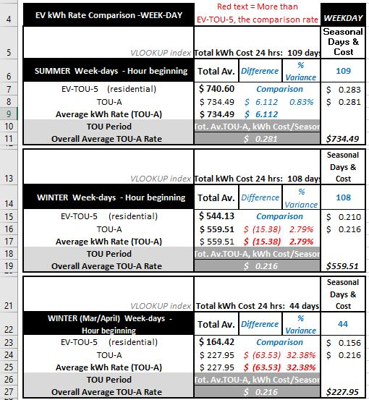

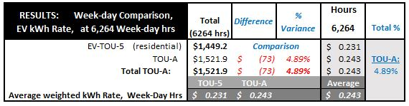
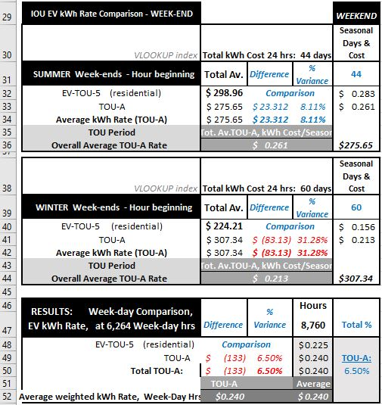

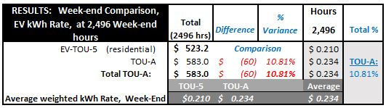

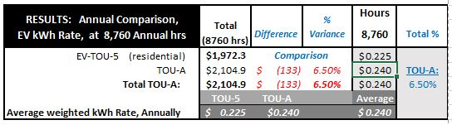

- Do you agree that based on the above data for these two Rate Schedules and Appendix Attachment 2 that the rates result in the following kWh average prices?

SDG&E Response: SDG&E objects to this request to the extent it seeks analysis not performed by SDG&E and is based on information equally available to SDAP.

  - EV TOU-5

    - Average kWh per Summer Weekdays: $ 0.283
    - Average kWh per Winter Weekdays: $ 0.210
    - Average kWh per Winter Weekdays (March/April): $ 0.156
    - Results: Average kWh per Weekdays: $ 0.231

    - Average kWh per Summer Weekends: $ 0.283
    - Average kWh per Winter Weekends: $ 0.156
    - Results: Average kWh per Weekends: $ 0.210

    - Results: Average kWh Annually: $ 0.225

  - TOU-A

    - Average kWh per Summer Weekdays: $ 0.281
    - Average kWh per Winter Weekdays: $ 0.216
    - Average kWh per Winter Weekdays (March/April): $ 0.216
    - Results: Average kWh per Weekdays: $ 0.243

    - Average kWh per Summer Weekends: $ 0.261
    - Average kWh per Winter Weekends: $ 0.213
    - Results: Average kWh per Weekends: $ 0.234

    - Results: Average kWh Annually: $ 0.240

  - Do these kWh averages appear correct?
  - If not, why not.
  - Please provide in a work paper, any corrections, and an explanation if you do not agree.

SDG&E Response: SDG&E objects to this request to the extent it seeks analysis not performed by SDG&E and is based on information equally available to SDAP.

- What is the Price Ratio % difference between the TOU Energy Price Rate Periods for each of the Following Rates?

    - EV TOU 5
    - TOU A
And in each of the following TOU energy rates:
  - TOU Energy Rate Ratio:

    - Weekday:
    - Summer Peak
    - Summer Off Peak
    - Summer SOP

    - Weekend:
    - Summer Peak
    - Summer Off Peak
    - Summer SOP

    - Weekday:
    - Winter Peak
    - Winter Off Peak
    - Winter SOP
    - Winter SOP March and April at 10am-2pm

    - Weekend:
    - Winter Peak
    - Winter Off Peak
    - Winter SOP

SDG&E Response: SDG&E objects to this request to the extent it seeks analysis not performed by SDG&E and is based on information equally available to SDAP.
SDG&E Response: SDG&E objects to this request as vague, ambiguous and speculative because it is based on an incomplete hypothetical. Accordingly, because SDG&E does not have sufficient knowledge or information upon which to admit or deny the claim, and on that basis denies that it is true.

- Time of Use Periods:
  - Do you agree, per the below items 1-3 that the following different TOU periods are present in SDGE’s current Tariff Schedules?

      - Two-Period and Weekends all Off-Peak
(for example, TOU-A and Residential Rate Schedules)

        - Summer - Peak and Off-Peak, Weekends all Off Peak
        - Winter - Peak and Off-Peak, Weekends all Off Peak

SDG&E Response: The TOU periods for SDG&E’s two-period standard TOU rates are below:

      - Three-Period and Winter only Weekends SOP until 2pm and March/April SOP 10am-2pm
(for example, TOU-M and EV TOU-5)

        - Summer 3 periods, Weekends are the same as Weekdays
        - Winter 3 periods, Weekends are longer SOP until 2pm
        - Winter 3 Periods, Weekdays March-April SOP 10-2pm

SDG&E Response: The TOU periods for SDG&E’s three-period standard TOU rates are below:

      - Three-Period and “All” Weekends SOP until 2pm and March/April SOP 10am-2pm
(for example, AL-TOU)

        - Summer 3 periods, Weekends are longer SOP until 2pm
        - Winter 3 periods, Weekends are longer SOP until 2pm Winter 3 Periods, Weekdays March-April SOP 10-2pm

SDG&E Response: The TOU periods for SDG&E’s three-period standard TOU rates are below:

  - Do you agree that in 1 and 2 above that these TOU Periods are used in both Residential Rates and Commercial rates?
SDG&E Response: Yes, the standard TOU 2-period and 3-period TOU are the same for both residential and commercial rates.

  - Does item 3 above, which is predominantly used in SDGE’s ML/CI Commercial rates, have any Residential rates with this TOU Period, if so which Tariff(s), please name them?
SDG&E Response: The TOU periods for items 2 and 3 are the same. Therefore, residential customers taking service on any residential rate schedule with standard TOU periods would have rates with these TOU periods.

- Street Lighting: Under Special Conditions in tariff OL-1 it states the utility's dusk to dawn, all-night service is based on a lighting period of approximately 4,165 hours per year.
  - Has SDGE implemented or developed a plan to replace streetlights in OL-1 Schedule?
    - If not, why not?
  - Do you agree that if LED lights were installed the kWh energy consumption would decrease for each of these customers?
    - If not, why not?
  - Do you agree that if LED lights were installed this would reduce and lower the GHG?
    - If not, why not?
  - Do you agree that when GHG is lowered that this would be in the Public Interest?
  - Has SDGE developed a process to report and confirm the status of all street lighting reliability at 4,165 hour per year? Per the Special Conditions provision, the light service is based off 4,165 hours per year.
    - If not, why not?
  - Do you agree that repairs, outages of lamps and bulbs can impact the 4,165 hours of service per year?
  - If impacted, do you agree that this will reduce the reliability of the service and can impact the customers operation?
  - Do you agree there is downtown in the program whereby customers are effectively paying for kWh consumption that they do not use due to this downtime and the lights not working and pending repairs?
    - If not, why not?

  - LED Lighting Savings per lamp. Do agree that there are customers not using 4,165 hours per year when lights go out?
  - How many repair order calls do you get per year, per month, in each Street lighting Tariff?
  - When is the last time that you upgraded the street lighting lamps in OL-1?

SDG&E Response:

        - SDG&E has a process in place for customers on Schedule OL-1 to notify SDG&E whenever there an issue with one of their OL-1 lamps so that, as stated in Special Condition 6 of Schedule OL-1, SDG&E is able to service the lamps, including replacing any burnt-out lamps, as quickly as possible. Based on the data request questions that follows this question it appears by replacing OL-1 lamps you mean replacing these lamps with light-emitting diode (LED) fixtures. As stated in the streetlighting supplemental testimony in SDG&E’s 2019 General Rate Case (GRC) Phase 2 Application (A.19-03-002), submitted on August 30, 2019, SDG&E is proposing to change out all its Schedule LS-1 lamps with LED fixtures, which is projected to take five years to complete. SDG&E has currently not developed a plan to replace Schedule OL-1 lamps with LED fixtures. However, SDG&E has informed SDAP that it is agreeable to propose the replacement of Schedule OL-1 lamps with LED fixtures in SDG&E’s next GRC Phase 2 proceeding (2024 GRC Phase 2).
        - Yes, SDG&E agrees that LED lamps are more energy efficiency and thus, the kWh consumption of LED lamps are less than comparable watt sized non-LED lamps.
        - Yes, as stated in response to Question 25.f.b above, LED lamps consume less energy than comparable watt sized non-LED lamps, which also means that LED lamps will result in reduced GHG emissions.
        - Yes, lower GHG emissions provide benefits to everyone and thus, lower GHG emissions are in the Public Interest.
        - SDG&E monitors the reliability of streetlighting by responding to repairs of streetlights when SDG&E is notified of issues with the lamp by the customer taking served on the lamp. As stated in Special Condition 6 of Schedule OL-1:
“Lamp maintenance will be done during regular working hours as soon as reasonably possible after customer has notified utility of service failure. Monthly bills will not be adjusted because of lamp outages.”
No process is in place to confirm whether the number of hours a lamp was operating in a given year was more or less than the 4,165 hours assumed.
        - Yes, outages of a lamp will impact the assumed 4,165 hours of service per year on the lamp. When a customer signs up for service on SDG&E owned streetlight such as Schedule OL-1, a letter is mailed to the customer stating that the customer needs to notify SDG&E when a lamp needs to be repaired and that the repair will be completed within 1-2 weeks.
        - Yes. As stated in response to Question 25.f.f above and Special Condition 6 of Schedule OL-1, customers are directed to notify SDG&E as soon as an issue with a lamp is detected so that the repair can be completed as quickly as possible to minimize the reduction in reliability of service and the impact to customer operations.
        - Non metered lighting service such as Schedule OL-1 are not billed rates based on the actual kWh consumption of the lamp but rather rates are developed per lamp based on a lighting period of approximately 4,165 hours per year. As stated in Special Condition 6 of Schedule OL-1, the customer’s monthly bill will not be adjusted because of lamp outages.
        - As stated in Special Condition 9 of Schedule OL-1, “[T]he utility's dusk to dawn, all-night service is based on a lighting period of approximately 4,165 hours per year.” As explained in respond to response to Questions 25.f.e and 25.f.f above, customers are directed to notify SDG&E as quickly as possible after a light goes out in order for SDG&E to get the light repaired as quickly as possible to limit the number of hours the light is out.
        - Below are the repairs by quarter in 2018 and 2019 for Schedule LS-1, SDG&E owned Street and Highway Service, and Schedule OL-1, SDG&E owned Outdoor Area Lighting Service.

        - Schedule OL-1 provides customers with optional outdoor lighting service where street and highway service lighting is not applicable. The lamps installed by SDG&E to take OL-1 service are SDG&E owned lamps installed to provide OL-1 lighting service. These lamps have been repaired and replaced over the years when needed with the last lamp replacement for service being provided to SDAP occurring on 5/18/20. As explained in response to Question 25.f.a above, SDG&E is agreeable to propose the upgrade of OL-1 lamps with LED fixtures in SDG&E’s 2024 GRC Phase 2.

