From: Tagnipes, Jeorge S. [mailto:jeorge.tagnipes@cpuc.ca.gov]
Sent: Thursday, April 07, 2016 3:45 PM
To: Best, Carmen
Cc: Skala, Pete
Subject: R.09-01-019 (RRIM Rehearing) Energy Division Response #04

Service List in R.09-01-019

Risk Reward Incentive Mechanism Rehearing – R.09-01-019
Energy Division Data Response 04
Updated: 4/7/2016
Intro: PG&E, SCE, SDG&E/SCG, and ORA submitted data requests to the Energy Division for the 2006-2008 Risk Reward Incentive Mechanism Rehearing. In an effort to ensure all parties have equal access to both the requested information and the responses, Energy Division requests the parties post these responses on their respective web sites and distribute the link to all parties in R. 09-01-019.

# | Requesting Party | Question | Response
1 | ORA | Question 1: Did the Commission and/or the Energy Division submit the 2006-2008 Energy Efficiency Evaluation Report to the California Energy Commission (CEC) for use in the Integrated Energy Policy Report (IEPR)? | Yes
2 | ORA | If the answer to question 1 is yes, please provide any additional available information about the submission of the 2006-2008 Energy Efficiency Evaluation Report to the CEC, and the CEC’s use of the 2006-2008 Energy Efficiency Evaluation Report for the IEPR process. | The 2011 IEPR report states that “staff leveraged the CPUC’s most recent efforts to measure utility program savings. The CPUC Energy Division’s evaluation-based estimates of program savings from 2006-2008 program cycle, as well as additional evaluation for 2009 programs, represent the most thorough and comprehensive effort to date”. See page 110 of the report.
3 | ORA | Question 3: Did the Commission and/or the Energy Division use or consider the 2006-2008 Energy Efficiency Evaluation Report for purposes other than the risk/reward incentive mechanism (RRIM) adopted in D.07-09-043, such as updating energy efficiency potential studies, including, but not limited to, the 2011 potential study under contract with Navigant Consulting? | Yes, the 2011 Potential model is calibrated to ex-post gross and net savings from the 2006-2008 EE Evaluation Report. See page 20 of report.
4 | ORA | If the answer to question 3 is yes, please list every purpose other than the RRIM for which the Commission and/or the Energy Division used the 2006-2008 Energy Efficiency Evaluation Report. | Energy Division also informed the Joint Agency Steering Committee (JASC) and the Demand Analysis Working Group (DAWG) of the 2006-2008 Energy Efficiency Evaluation Report.
5 | ORA | Question 5: Did the Commission and/or the Energy Division submit the 2006-2008 Energy Efficiency Evaluation Report to the California Independent System Operator (CAISO) for use in the Transmission Planning Process (TPP)? | The CAISO started incorporating EE forecasts into their planning process for this most recent cycle, so the 2006-2008 results would not have been relevant.
6 | ORA | If the answer to question 5 is yes, please provide any additional available information about the submission of the 2006-2008 Energy Efficiency Evaluation Report to the CAISO and the CAISO’s use of the 2006-2008 Energy Efficiency Evaluation Report for the TPP process.
7 | SDGE | By email requesting the password for the Risk Reward Templates | VRTRRIM
8 | SDGE | By email requesting guidance on how to import text files into Access | Open Access and click “External Data” and click “Text File”  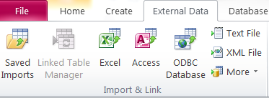  Then when I found the text files, I selected “Delimited” and for the delimiter it looked “pipe-delimited” 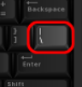 so I entered that in “other”:  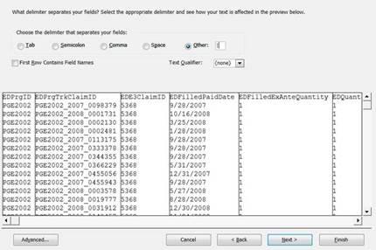

Jeorge S. Tagnipes | 415.703.2451 | jeorge.tagnipes@cpuc.ca.gov | Energy Division | www.cpuc.ca.gov/lap

